St Saviour’s Catholic Primary and Nursery School


Subject: Science
Topic: Scientists and Inventors | Year: 5
Vocabulary
Biology- The study of living things.
Naturalist- A person who studies plants and animals and their environments
Species- A group of similar organisms that are able to reproduce.
Physicist- A scientist who specialises in the study of physics, which includes electricity, astronomy, forces, light and sound.
Endangerment: The action of putting someone or something at risk or in danger.
Programming: The process of writing computer programs.
Engineer: Someone who is involved in inventing, designing and maintaining a variety of machines, structures and data systems.

What should I already know?
- Gerald Durrell was a conservationist who worked hard to save Madagascar’s unique plants and animals
- Alexander Graham Bell was a Scottish scientist and inventor. His most famous invention was the first telephone

Who am I going to learn?
- David is a naturalist who has written and presented many popular documentaries about animals and their behaviour.

- Eva Crane was a physicist who became interested in bees’ behaviour and their life cycle. She studied bees all around the world and wrote many books about her discoveries.

- Margaret Hamilton worked for NASA and was responsible for programming the onboard flight software on the Apollo spacecraft computers. She wrote the code that the computer used to navigate from Earth to the Moon and made sure that the computer would land the spacecraft safely on the Moon.

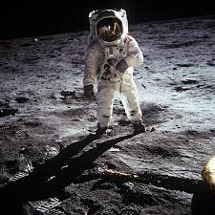
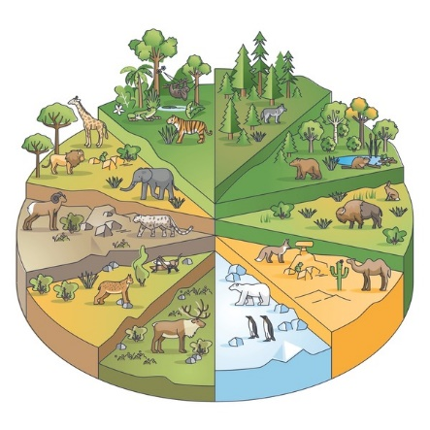

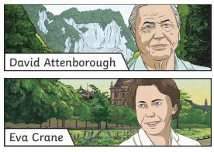
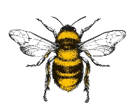

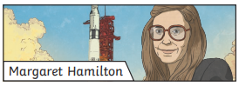
Useful websites:
https://kids.britannica.com/kids/article/David-Attenborough/633494
https://www.youtube.com/watch?v=wD7GmF2mzdc
https://www.evacranetrust.org/page/eva-crane

